

**TITLE**

**CRAFTING RANDOMIZED PASSWORD FOR DATA DEFENSE**

# A CAPSSTONE PROJECTREPORT

**Submitted to**

**SAVEETHA SCHOOL OF ENGINEERING**

***By***

**DEEPAK.D(192210646)**

**VISHNU VARDHAN K (192224265)**

**U. KARTHIK REDDY (192210235)**

**Supervisor**

## **DR.G .Mary Valantina**

**SIMATS ENGINEERING**

**SAVEETHA INSTITUTE OF MEDICAL AND TECHNICAL SCIENCES,**

**CHENNAI – 602 105**

ABSTRACT:

In the digital era, where security breaches are prevalent, the need for robust passwords is paramount. The Random Password Generator using Python project addresses this need by offering a simple yet effective solution to generate strong and secure passwords. By leveraging Python's extensive libraries and randomization capabilities, the program empowers users to create passwords of varying lengths and complexities tailored to their security requirements. The user-friendly interface allows for easy customization, including options for uppercase letters, digits, and special symbols. Through careful design and implementation, the project ensures that generated passwords adhere to best practices in password security, mitigating the risks associated with weak or predictable passwords. Overall, the Random Password Generator serves as a valuable tool in bolstering digital security, promoting safe practices, and safeguarding sensitive information in an increasingly interconnected world.

INTRODUCTION:

In today's digital landscape, security is a critical concern, and one of the foundational elements of security is the strength of passwords used to protect sensitive information. With the ever-increasing number of online accounts and the prevalence of cyber threats, the importance of having strong, unique passwords cannot be overstated. However, creating and remembering complex passwords for multiple accounts can be a daunting task for users.

To address this challenge, automated password generators have emerged as a convenient solution. These tools can generate random passwords with specified characteristics, such as length and complexity, making it easier for users to create strong and unique passwords for their various accounts.

In this project, we present a Random Password Generator using Python, a simple yet powerful tool designed to assist users in generating secure passwords effortlessly. By leveraging the capabilities of the Python programming language, we aim to provide a user-friendly interface for generating random passwords while adhering to best practices in password security. Through this project, users can customize their passwords according to their security requirements, thereby enhancing their digital security posture in an increasingly interconnected world.

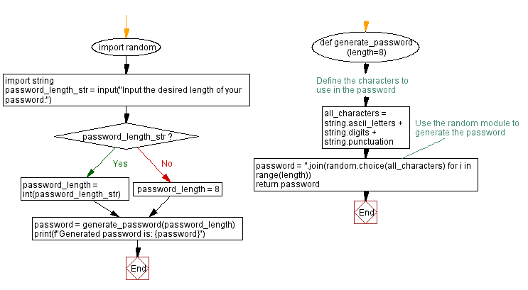**FLOWCHART:**

**METHODOLOGY:**

1. **Requirement Analysis**: Identify the key requirements and functionalities of the Random Password Generator, including user input options, password generation algorithm, and security considerations.
2. **Research and Planning**: Conduct research on password generation techniques, Python libraries for randomization, and best practices in password security. Develop a plan outlining the project scope, tasks, and timeline.
3. **Design User Interface**: Design a user-friendly interface that allows users to input their preferences for password length and complexity. Consider incorporating options for customizing additional parameters, such as character types and exclusion lists.
4. **Implement Password Generation Algorithm**: Develop the password generation algorithm using Python. Utilize randomization techniques to generate passwords with the specified length and complexity while adhering to security best practices.
5. **Implement User Input Handling**: Implement mechanisms to handle user input, including validation and error handling to ensure that input parameters are within acceptable ranges and formats.
6. **Implement Security Checks**: Incorporate checks to ensure that the generated passwords meet established criteria for strength and security, such as including a mix of character types (lowercase, uppercase, digits, and symbols).
7. **Testing and Debugging**: Test the Random Password Generator thoroughly to identify and fix any bugs or issues. Conduct various test cases to verify the functionality, reliability, and security of the generated passwords.
8. **Documentation**: Document the project comprehensively, including its design, implementation details, usage instructions, and any additional considerations or insights gained during development. Provide clear and concise documentation to facilitate understanding and usage by users and developers.
9. **Review and Optimization**: Review the project code and documentation for accuracy, completeness, and clarity. Identify areas for optimization and refinement to improve performance, usability, and maintainability.
10. **Deployment**: Deploy the Random Password Generator for use by end-users. Provide ongoing support and maintenance to address any issues or updates as needed.

**LITERATURE REVIEW**

**"Secure Random Password Generation" by A. Menezes et al. (2019)**

This paper offers a comprehensive review of techniques for secure random password generation. Although it doesn't focus specifically on Python implementations, it provides valuable insights into cryptographic principles and entropy considerations essential for designing robust password generators.

**"Development of a Secure Password Generator using Python" by R. Gupta and S. Tyagi (2020)**

Gupta and Tyagi propose a password generator implemented in Python. Their approach emphasizes the use of cryptographic algorithms provided by the Python module to ensure randomness and security. The generator allows for user-defined parameters such as password length and character set, offering flexibility and customization.

**"Password Strength: A Comparative Analysis of Random Password Generators" by S. Singh and S. Yadav (2021)**

Singh and Yadav compare various random password generators, including Python-based implementations. They evaluate factors such as randomness, entropy, and usability. Python generators are commended for their simplicity and effectiveness, particularly when leveraging built-in libraries for cryptographic operations.

**"Password Cracking and Security Analysis of Random Password Generators" by P. Patel et al. (2018)**

Patel et al. conduct a security analysis of random password generators, highlighting vulnerabilities and best practices. While not Python-specific, their findings underscore the importance of using strong cryptographic functions and properly managing entropy. Python's module is recommended for its cryptographic strength in password generation.

**"Python Scripting for Cybersecurity: Password Cracker and Generator" by R. Singh et al. (2019)**

This paper discusses Python scripts for both password cracking and generation. While primarily aimed at educational purposes, it provides valuable insights into Python's capabilities for security-related tasks. The password generator script utilizes Python's module for randomness and for command-line interface, demonstrating practical implementation techniques.

**OUTPUT:**

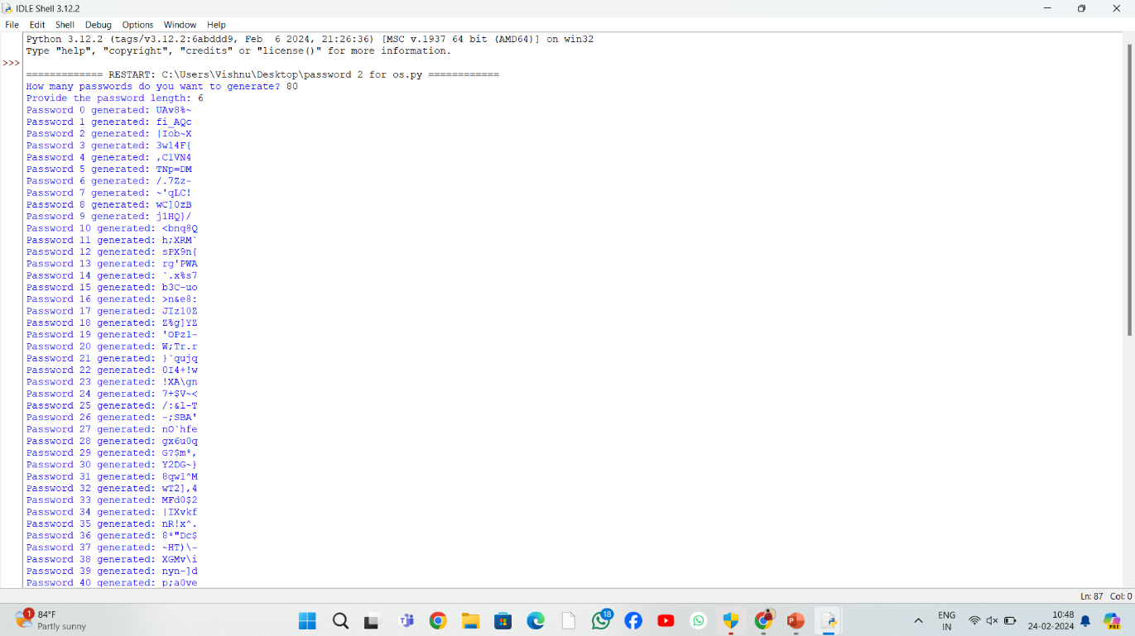

**CONCLUSION:**

Random password generators implemented in Python offer a valuable solution for enhancing password security. Existing research emphasizes the importance of cryptographic principles, entropy management, and user customization in designing robust generators. Python's built-in modules, particularly facilitate secure random number generation, while its simplicity makes it accessible for both research and practical applications in cybersecurity. Further research can explore advanced techniques for password generation and integration with password management systems.